Supplementary Materials for

**High-resolution lithospheric structure of continental China from joint inversion of surface wave and gravity data**

Aowei Hao1, Haijiang Zhang1,2*, Shoucheng Han1, Monica Maceira3

1. University of Science and Technology of China, School of Earth and Space Sciences, Hefei, Anhui, China
2. Mengcheng National Geophysical Observatory, University of Science and Technology of China, Hefei, Anhui, China
3. Oak Ridge National Laboratory, Oak Ridge, TN, USA

**Contents of this file**

Figs. S1-S18

Text S1

Figures

Fig. S1. Filtered Bouguer gravity data by a median filter for continental China and surrounding areas with different radii

Figure S2. (a) Initial 1-D Vs model. (b), (c) and (d) are the L-curves for determining optimal parameters ,, andfor joint inversion, respectively.

Figure S3. RMS phase velocity residuals at periods of 8-30 s for surface-wave inversion (first and third columns) and joint inversion (secondand fourth columns), respectively.

Figure S4. The same as Figure S3 but at periods of 32-70 s.

Figure S5. RMS group velocity residuals at periods of 8-30 s for surface-wave inversion (first and third columns) and joint inversion (secondand fourth columns)

Figure S6. The same as Figure S5 but for periods of 32-50 s.

Figure S7. Semblance tests for surface-wave inversion (first column) and Joint inversion (second column) at depths of 5-40 km.

Figure S8. The same as Figure S7 but at depths of 60-120 km.

Figure S9. The fitting of Rayleigh wave phase and group velocities at selected 12 points for joint inversion. The location of these points (A-L) can be seen in Fig. 5.

Figure S10. Vertical cross sections of the density model of continental China along W-E profiles AA’, BB’, CC’ and DD’ and S-N profiles of EE’, FF’, GG’, and HH’, respectively. The location of the profiles is shown in Fig.5. The black dashed line is the Moho from He et al (2014) and the blue dashed line is the Moho from Airy gravity isostatic equilibrium hypothesis described in Text S1.

Figure S11. Comparison of Vs models at depths of 5-40 km from (left column) this study, (middle column) USTClitho2.0, and (right column) Shen et al. (2016).

Figure S12. Same as Fig.S11 but for depths between 60-120 km.

Figure S13. The sensitivity kernels of surface wave data. (a) and (b) are the sensitivity kernels of Rayleigh wave phase velocity at different periods, and (c) and (d) are the sensitivity kernels of Rayleigh wave group velocity at different periods. The periods are 8s, 16s, 26s, 30s, 40s, and 50s.

Figure S14. Depth slices of Vs models from surface wave inversion (left column), joint inversion and Tang et al (2022) at depths of 5, 15,30, and 40 km.

Figure S15. Same as Fig. S14 but at depths of 60, 80,110 and 120 km

Figure S16. Vertical cross sections of the joint inversion Vs model along four nearly NS profiles (AA’, BB’, CC’, and DD’) beneath the TP. The location of the four profiles is shown in Fig. 13a, and the white dashed line denotes the possible subduction angle of the India plate.

Figure S17. Depth slices of the Vs models at depths of 90, 100 and 120 km for (left) the joint inversion and (right) the surface wave inversion beneath the Tibetan Plateau, respectively. The symbols are the same as Fig. 13.

Fig. S18 The sketch of Airy isostatic equilibrium. h is the expected topography, t is the average crustal thickness, and r is the root of mountain.

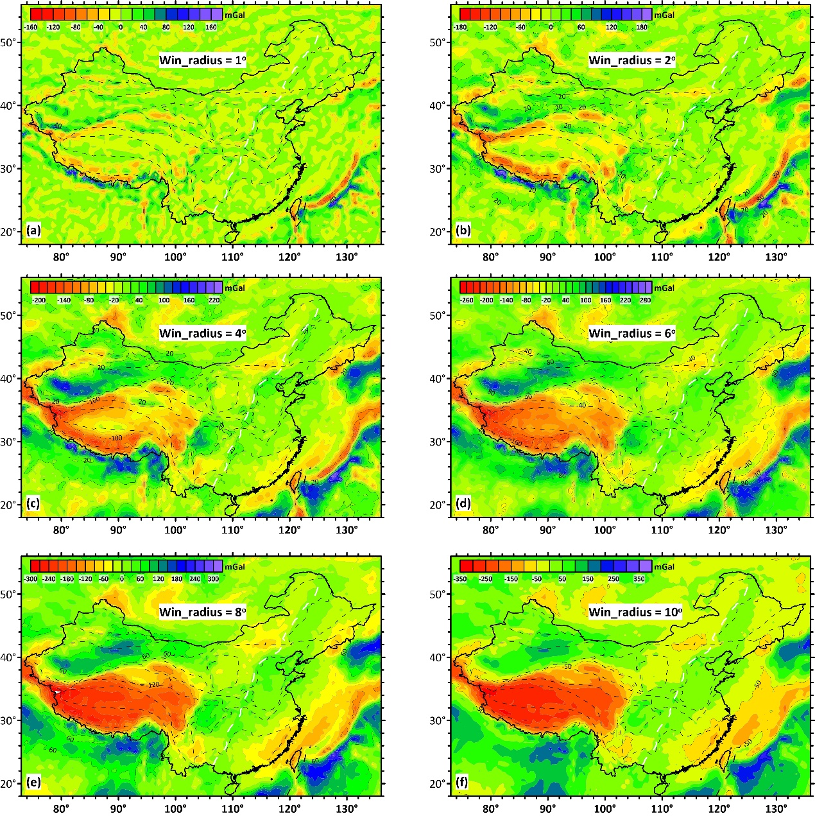

Fig S1. Filtered Bouguer gravity data by a median filter for continental China and surrounding areas with different radii

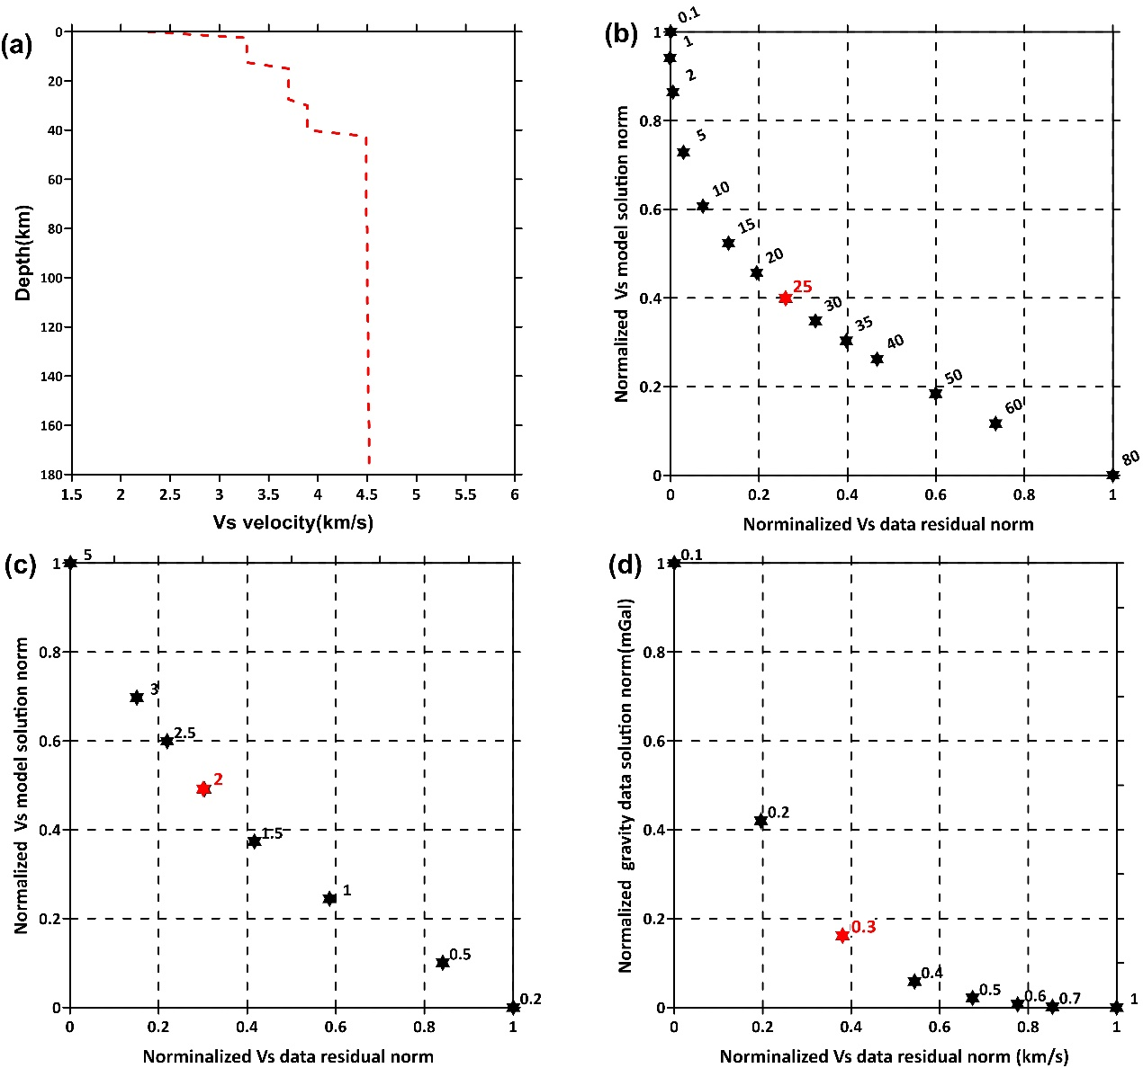

Figure S2. (a) Initial 1-D Vs model. (b), (c) and (d) are the L-curves for determining optimal parameters ,, andfor joint inversion, respectively.

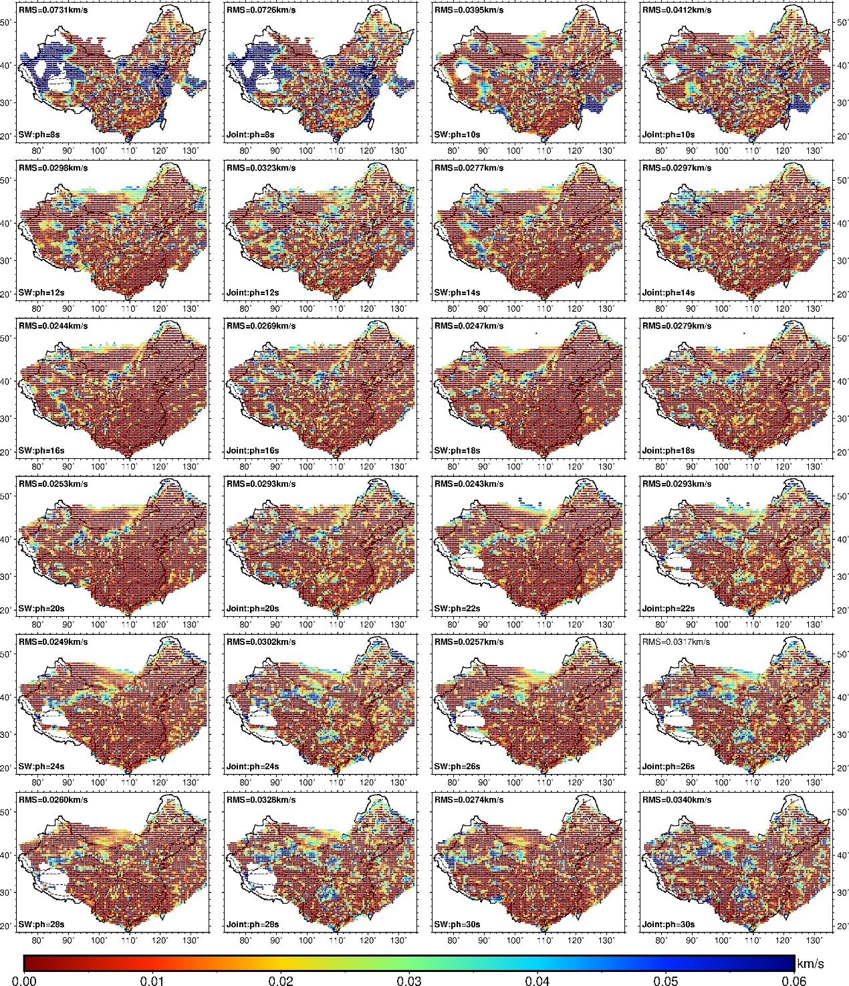

Figure S3. RMS phase velocity residuals at periods of 8-30 s for surface-wave inversion (first and third columns) and joint inversion (secondand fourth columns), respectively.

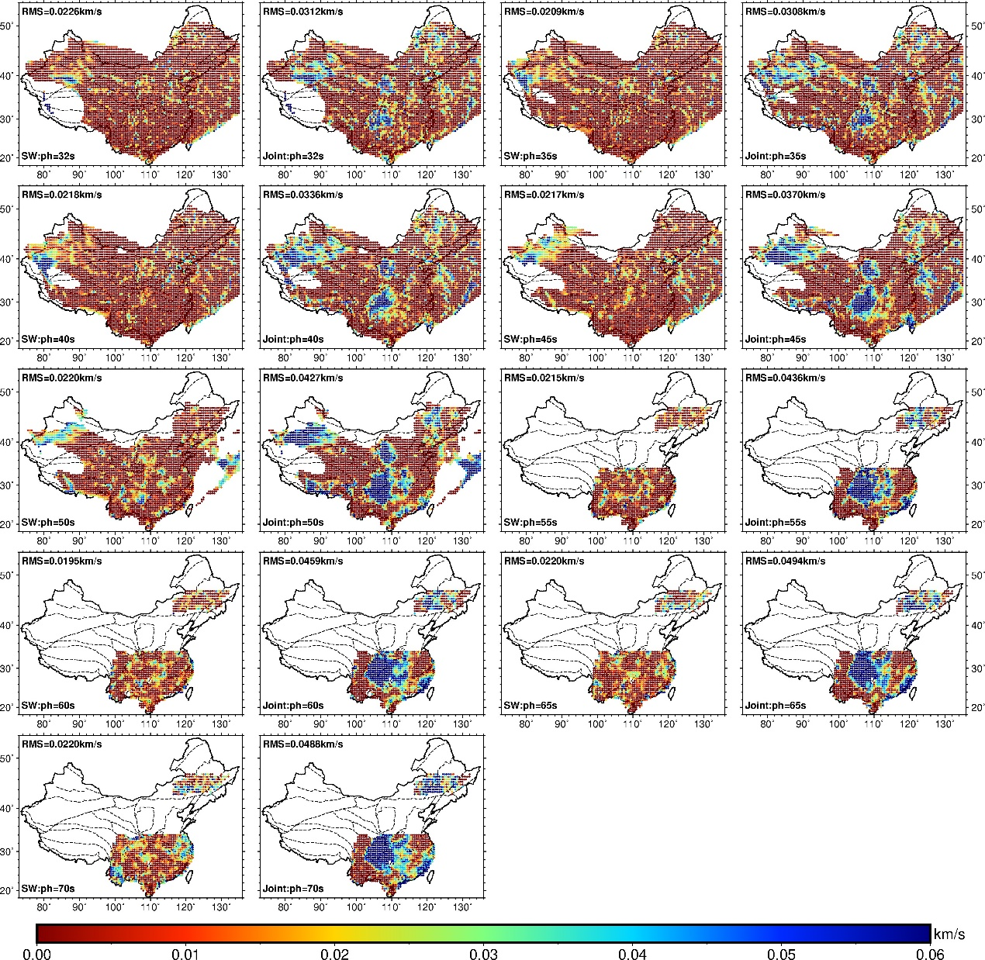

Figure S4. The same as Figure S3 but at periods of 32-70 s.

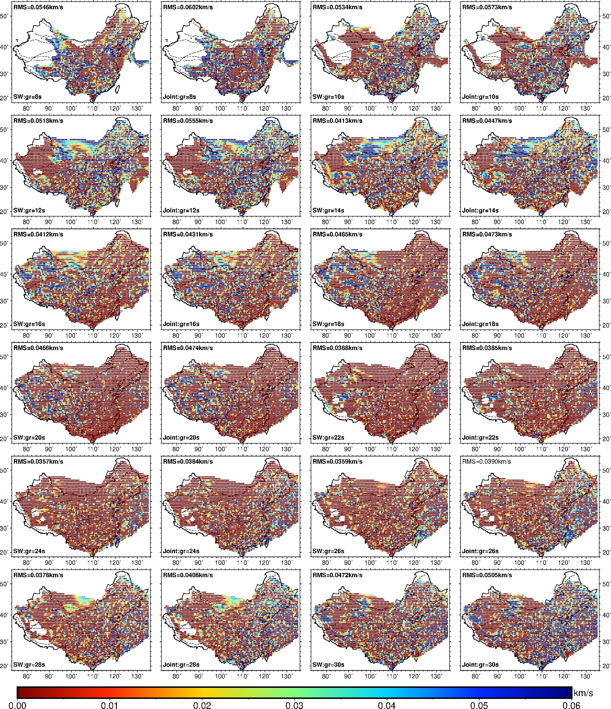

Figure S5. RMS group velocity residuals at periods of 8-30 s for surface-wave inversion (first and third columns) and joint inversion (secondand fourth columns)

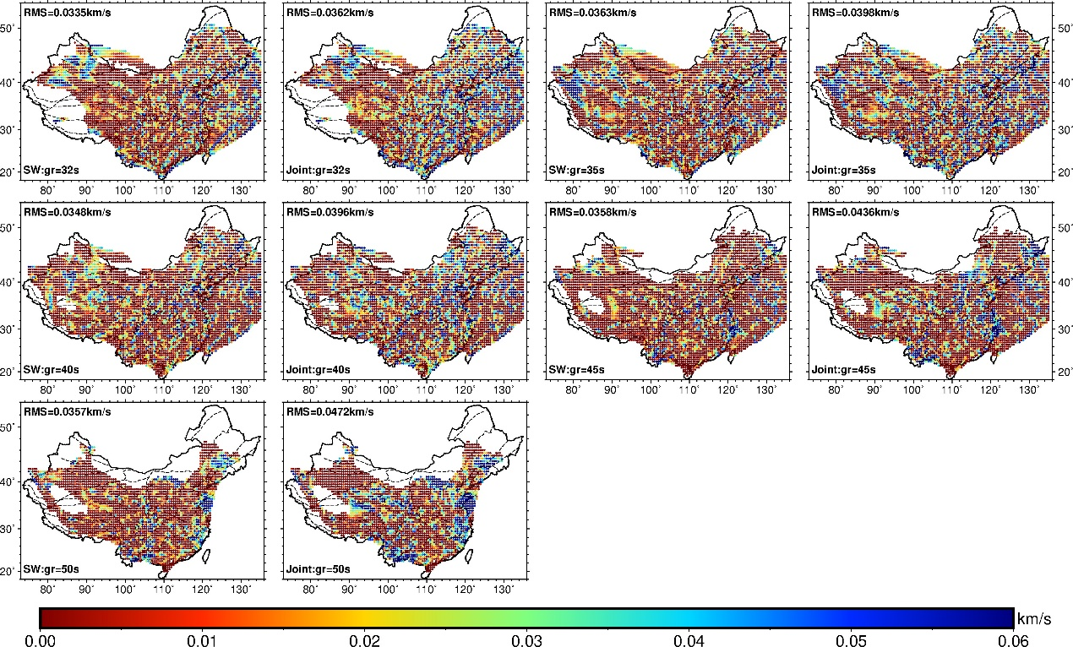

Figure S6. The same as Figure S5 but for periods of 32-50 s.

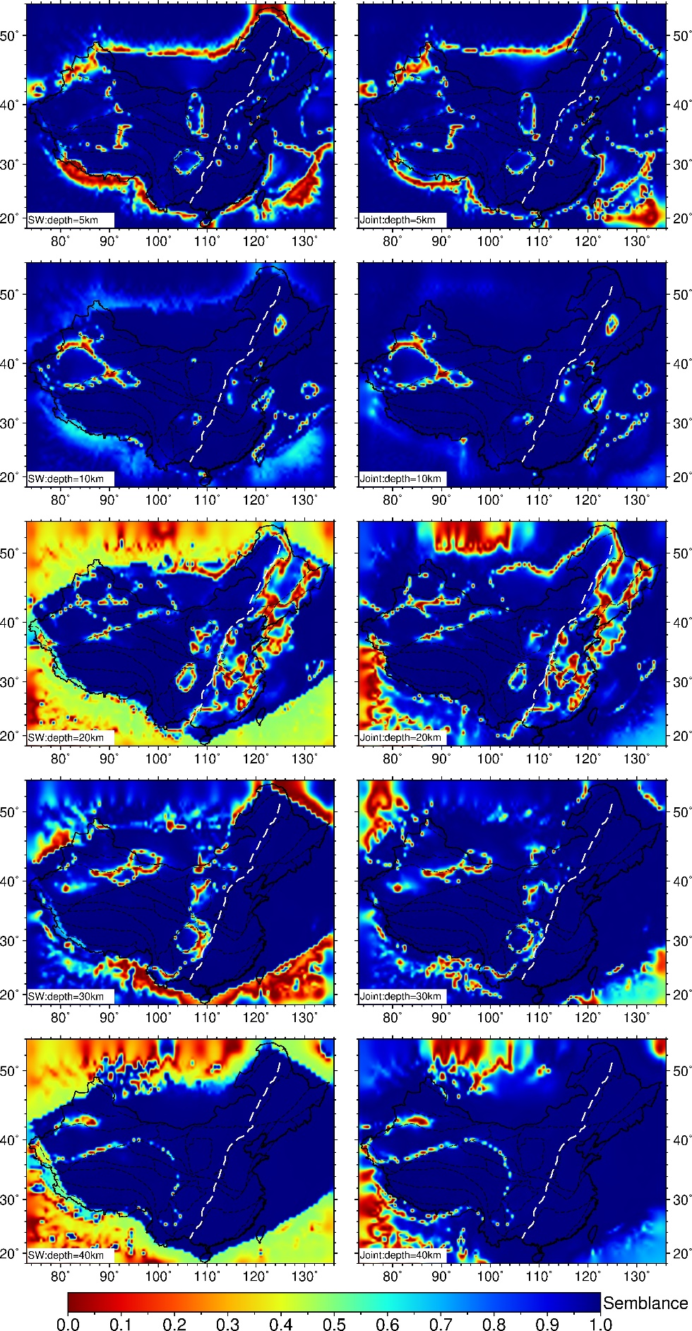

Figure S7. Semblance tests for surface-wave inversion (first column) and Joint inversion (second column) at depths of 5-40 km.

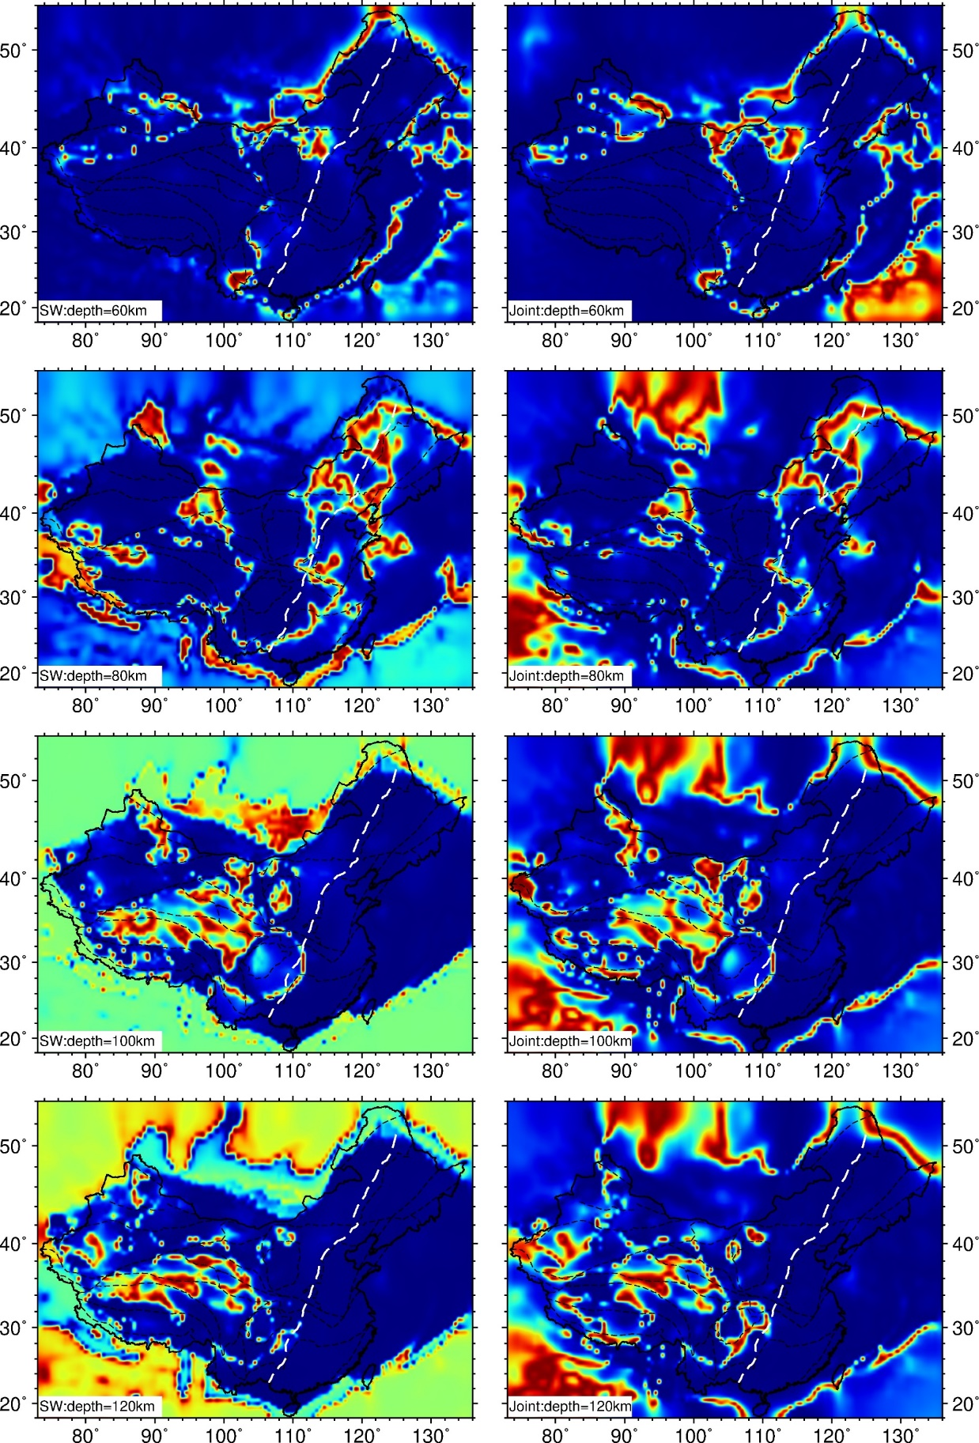

Figure S8. The same as Figure S7 but at depths of 60-120 km.

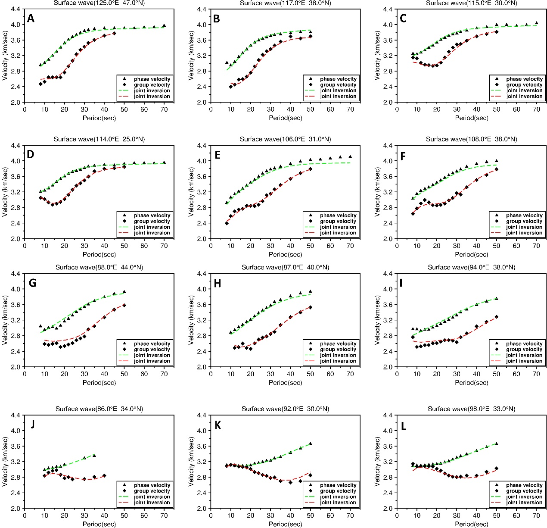

Figure S9. The fitting of Rayleigh wave phase and group velocities at selected 12 points for joint inversion. The location of these points (A-L) can be seen in Fig. 5.

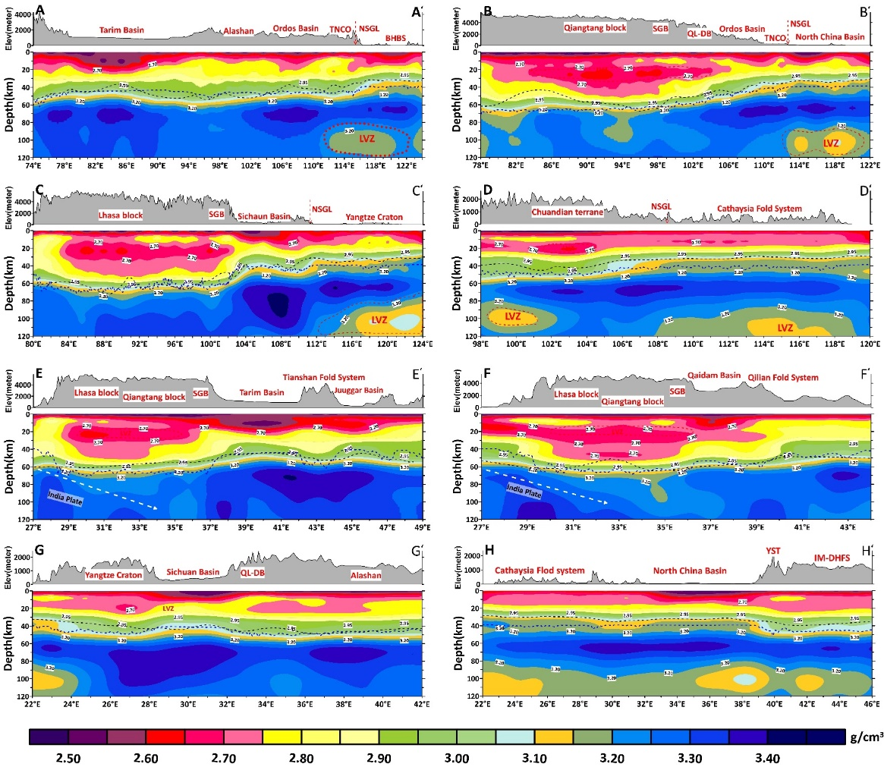

Figure S10. Vertical cross sections of the density model of continental China along W-E profiles AA’, BB’, CC’ and DD’ and S-N profiles of EE’, FF’, GG’, and HH’, respectively. The location of the profiles is shown in Fig.5. The black dashed line is the Moho from He et al (2014) and the blue dashed line is the Moho from Airy gravity isostatic equilibrium hypothesis.

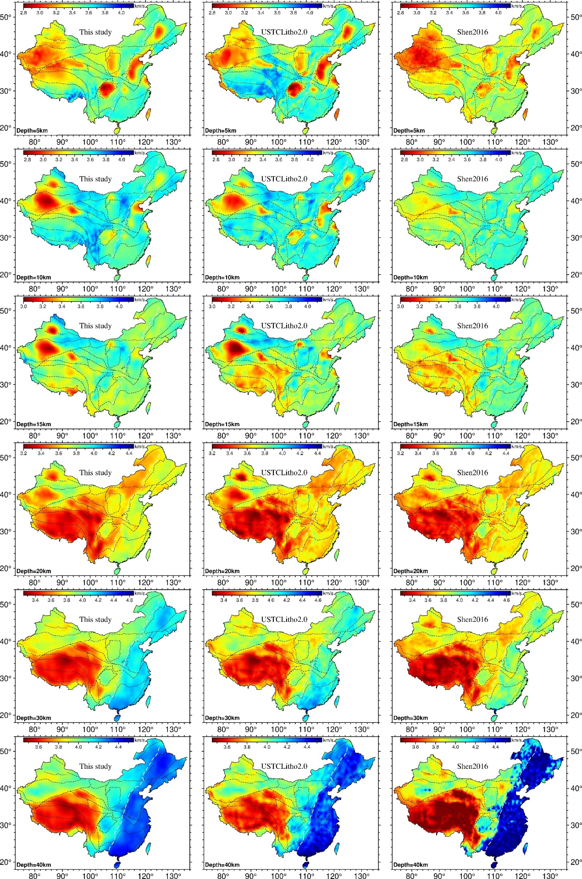

Figure S11. Comparison of Vs models at depths of 5-40 km from (left column) this study, (middle column) USTClitho2.0, and (right column) Shen et al. (2016).

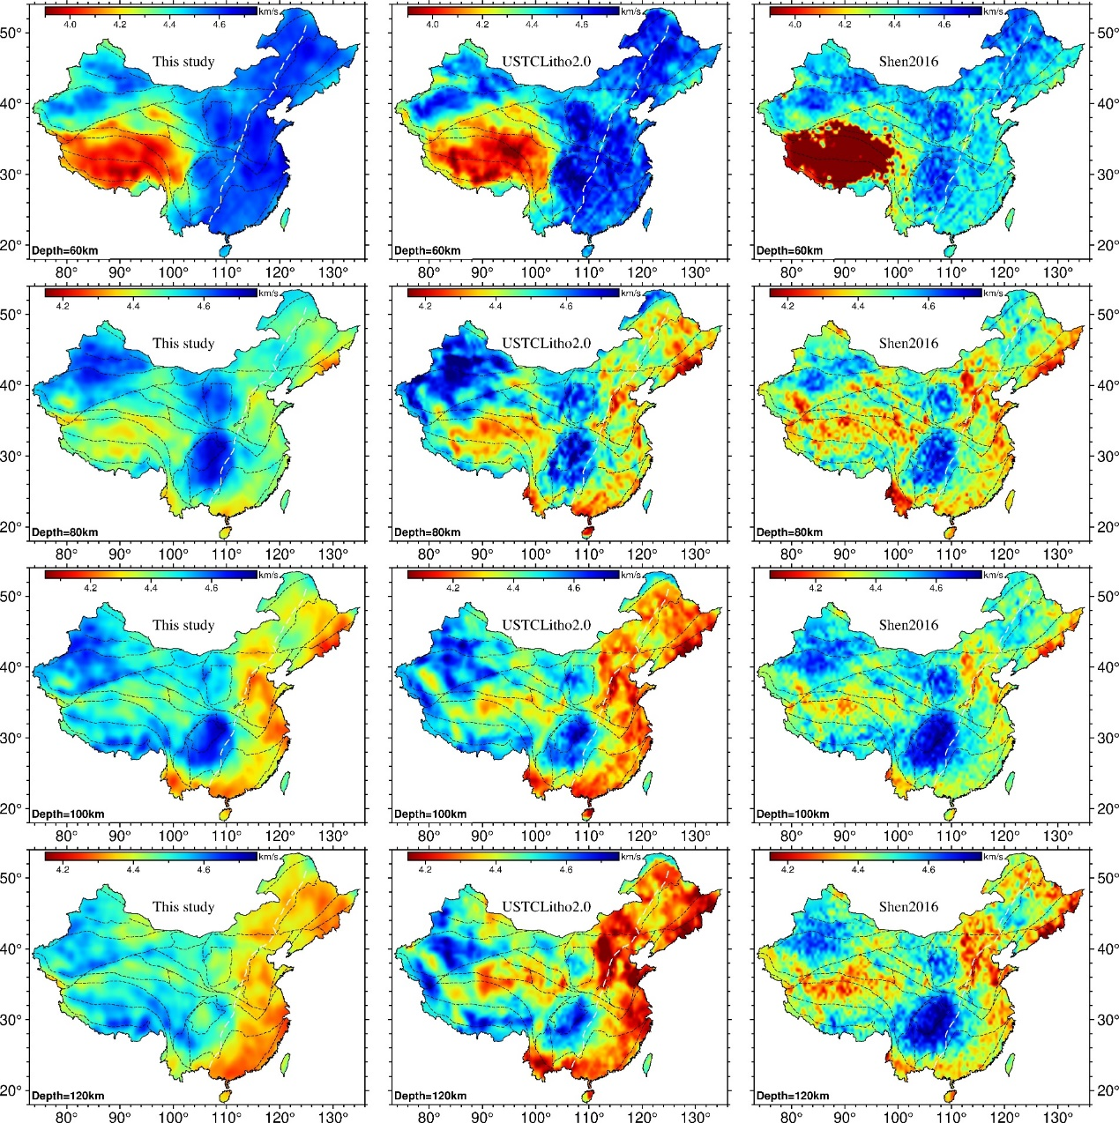

Figure S12. Same as Fig.S11 but for depths between 60-120 km.

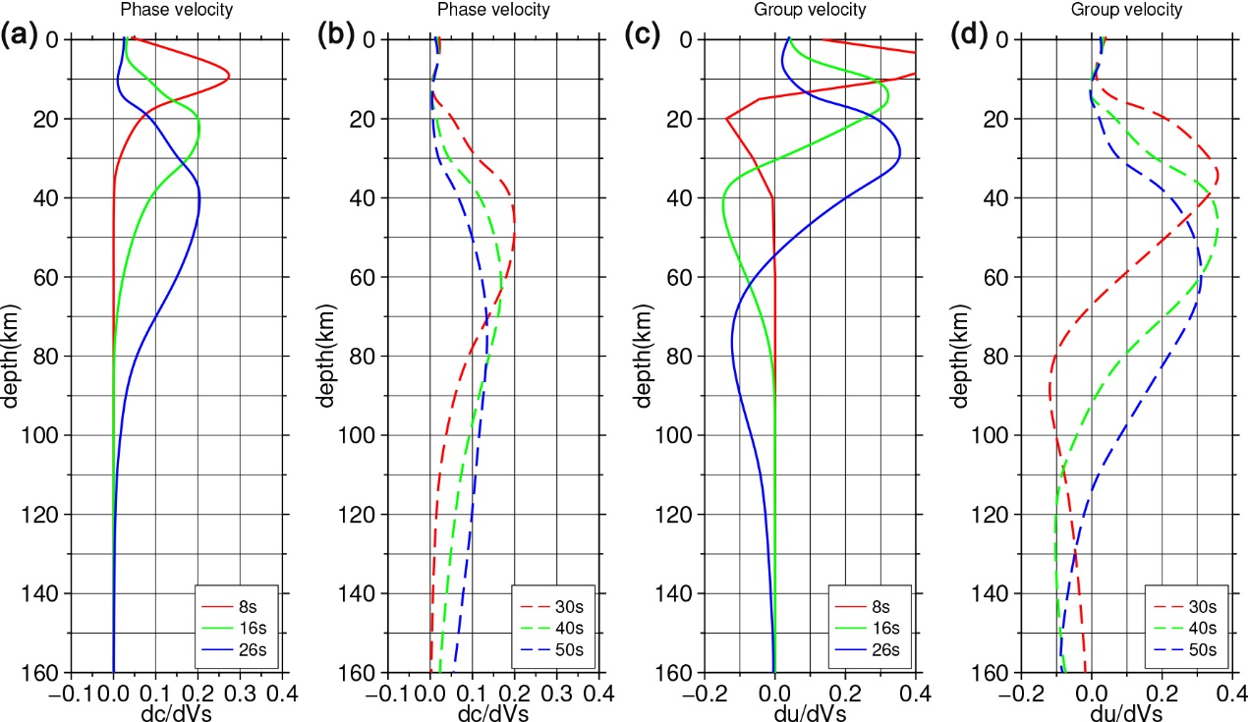

Figure S13. The sensitivity kernels of surface wave data. (a) and (b) are the sensitivity kernels of Rayleigh wave phase velocity at different periods, and (c) and (d) are the sensitivity kernels of Rayleigh wave group velocity at different periods. The periods are 8s, 16s, 26s, 30s, 40s, and 50s.

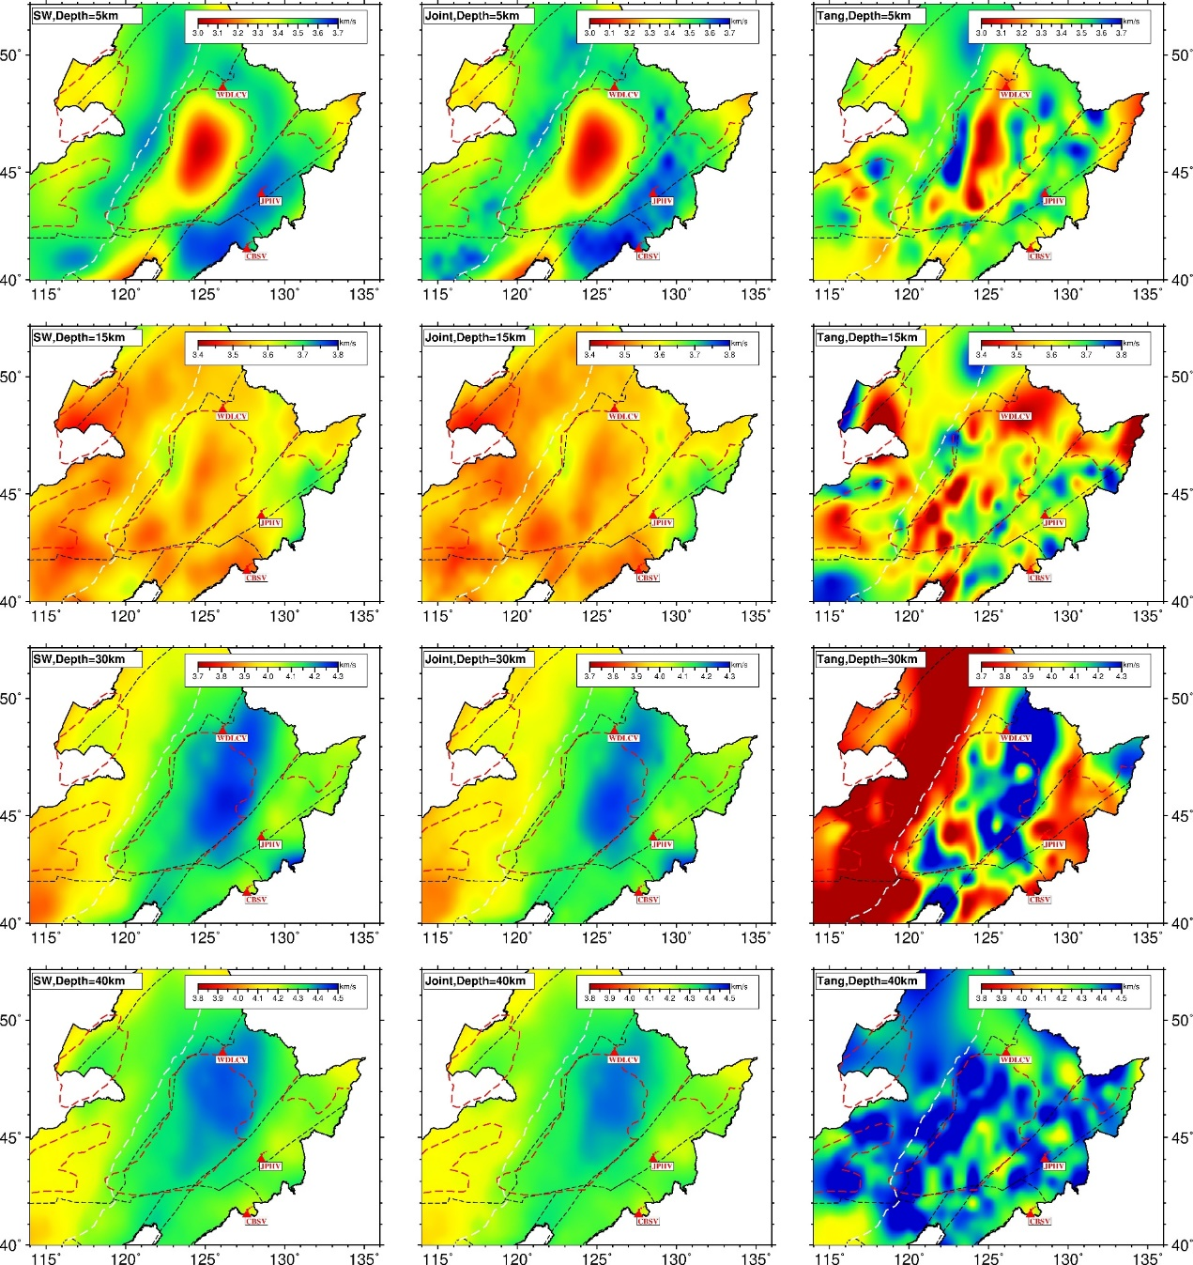

Figure S14. Depth slices of Vs models from surface wave inversion (left column), joint inversion and Tang et al (2022) at depths of 5, 15,30, and 40km

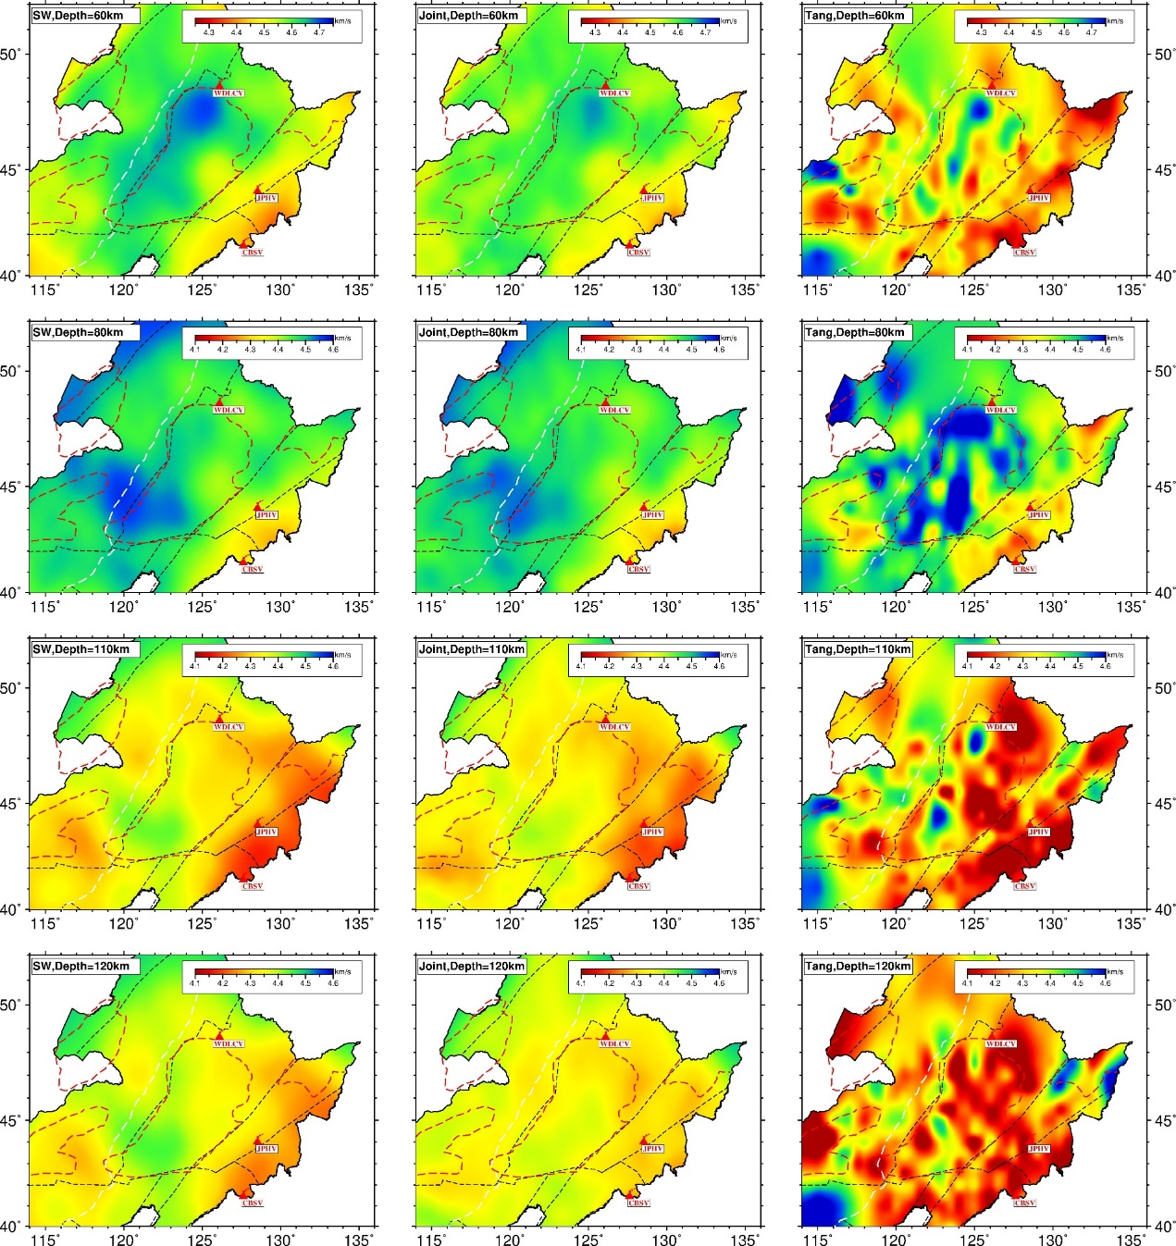

Figure S15. Same as Fig. S14 but at depths of 60, 80,110 and 120 km

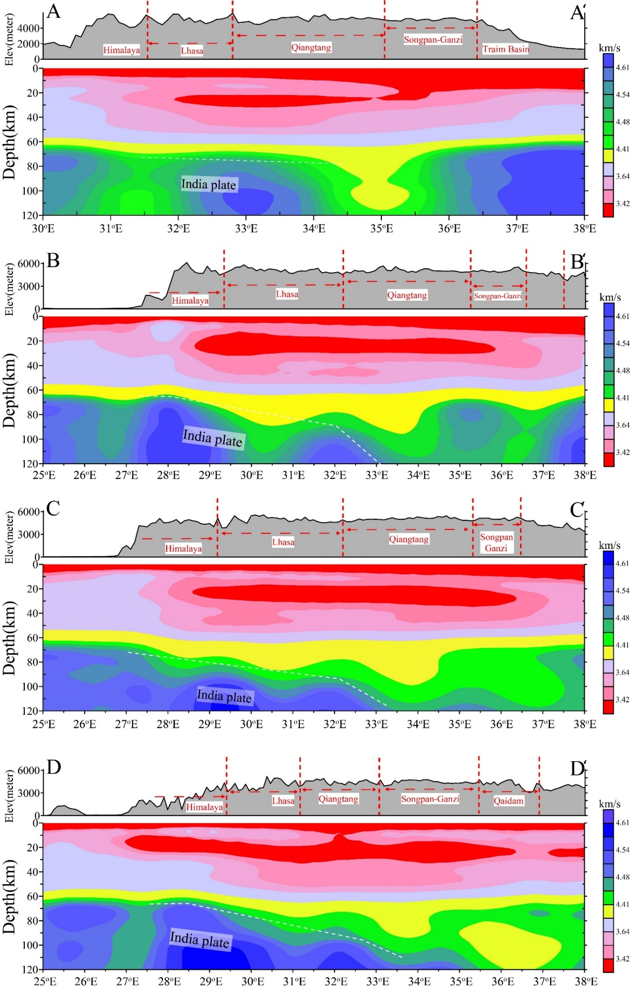

Figure S16. Vertical cross sections of the joint inversion Vs model along four nearly NS profiles (AA’, BB’, CC’, and DD’) beneath the TP. The location of the four profiles is shown in Fig. 13a, and the white dashed line denotes the possible subduction angle of India plate.

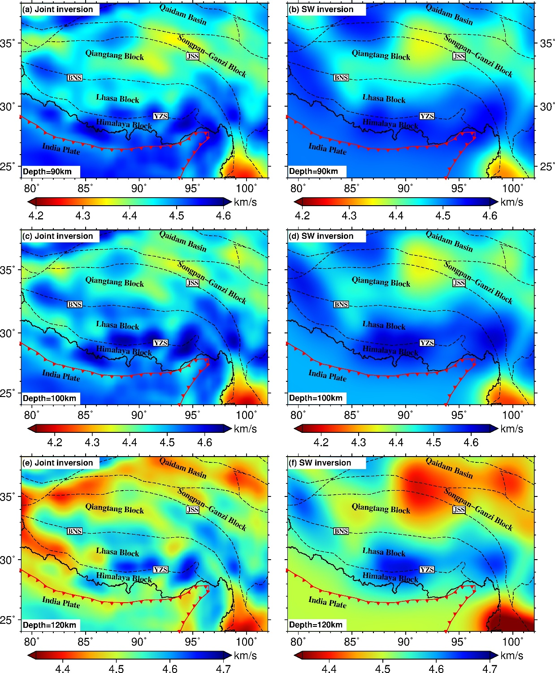Figure S17. Depth slices of the Vs models at depths of 90, 100 and 120km for (left) the joint inversion and (right) the surface wave inversion beneath the Tibetan Plateau, respectively. The symbols are the same as Fig. 13.

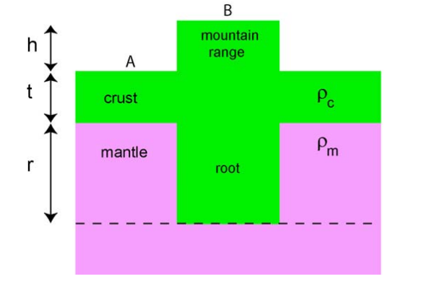

Fig. S18 The sketch of Airy isostatic equilibrium. h is the expected topography, t is the average crustal thickness, and r is the root of mountain.

Text S1. Estimate the Moho based on Airy isostatic equilibrium hypothesis

In the Airy isostatic hypothesis, the mountain range can be thought of as a block of lithosphere floating in the asthenosphere. Mountains have roots, while ocean basins have anti-roots. The sketch can be seen in Fig. S18.

If the system is stable (no external forces) it is said to be in the isostatic equilibrium. At the compensation depth, the pressure due to materials above is constant at all positions (below this depth the Earth behaves as liquids).

A plateau of height h is supported by a crustal root of depth r. The normal crustal thickness is t. Pressure at a depth h in a medium of density ρ is given by P = ρgh. By equating the pressures at the compensation depth at ‘A’ and ‘B’ we can write:

$tρ_{c}+rρ_{m}=(h+t+r)ρ_{c}$ (S1)

The above formula (S1) can be simplified as

$rρ_{m}=hρ_{c}+rρ_{c}$ (S2)

where $ρ_{c}$ and $ρ_{m}$ are crustal and mantle densities, respectively. By Rearranging equation (S2), the thickness of the crustal root can be obtained,

$r= \frac{ρ_{c}}{ρ_{m}-ρ_{c}}h$ (S3)

For the Moho depth,

$H_{moho}=t+r=t+\frac{ρ_{c}}{ρ_{m}-ρ_{c}}h$ (S4)

If =2.7 g/cm3, =3.3g/cm3, the average normal crustal thickness of continental China is about 39 km (He et al, 2014). The Moho based on Airy isostatic equilibrium can be approximated as

$H_{moho}=39+5.4h$ (S5)

We draw the approximated Moho depth by $H_{moho}=39+5.4h$ in Fig. 7 (see blue dashed line).

**References**

He R, Shang X, Yu C, Zhang H, Hilst RDVd. 2014. Detailed Moho Depth Mapping of Continental China by Receiver Function Analysis[J]. *Geophys. J. Int.*, **199**: 1910-1918.

Tang Z, Julià J, Mai PM, Mooney WD, Wu Y. 2022. Shear‐Wave Velocity Structure Beneath Northeast China From Joint Inversion of Receiver Functions and Rayleigh Wave Phase Velocities: Implications for Intraplate Volcanism[J]. *J Geophys Res:Solid Earth*, **127**(5)